KAYSVILLE
Police Department

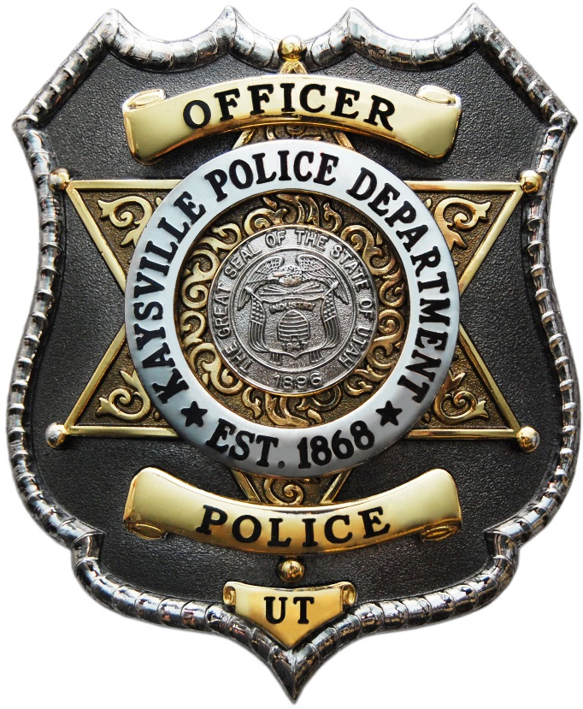

Annual Report
2024

Table of Contents
Table of Contents 1
2025 Organizational Chart 3
Mission Statement 5
Vision Statement 6
Oath of Honor 6
Core Values & Value Statement 7
Activity Summary 8
Police Service Calls 9
Police Service Calls & Traffic Stops Time Analysis 10
Cases 11
Arrests 12
Arrest Demographics 12
Traffic Statistics 13
Traffic Stops and Citations 13
Accidents 13
Investigations Division 14
Registered Sex Offenders 15
Training 16
National Prescription Drug Take Back 17
Jason W. Read Protect and Serve Foundation Donation 18
New Officer 19
#copsandlemonade Challenge 20
Cops and Kids Event 21
SafeWise Utah’s Safest Cities Report 22
Records and Evidence 23
Department Awards 24

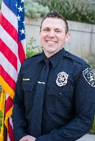
SRO Centennial Jr
Robert Jackson
Kaysville Police Department
2024 Organizational Chart

Mission Statement

The mission of the Kaysville Police Department is to protect the lives, property, and rights of all people through prevention, professionalism, and partnership with our community, as guided by the Constitution of this great state and country.
We will enforce the law impartially with a reverence for human life and provide service with compassion, integrity, and honor.

Vision Statement

Through innovation and a commitment to excellence, the Kaysville Police Department strives to offer exemplary service and unparalleled professionalism while continuing a dedication to enhancing community partnerships.

Oath of Honor

On my honor, I will never betray my badge, my integrity, my character, or the public trust.
I will always have the courage to hold myself and others accountable for our actions.
I will always uphold the Constitution and the community I serve.

Core Values & Value Statement

Excellence
Trust
Honor
Integrity
Community
Service

Kaysville Police Department members believe demonstrating integrity in all situations is paramount to earning the trust and confidence of our community.
We are dedicated to serving with respect and empathy in a professional, impartial manner.
Our commitment to excellence will enhance the quality of service to the community and uphold the honor of our profession.

Activity Summary
 | 2023 | 2024 | % Change
Total Service Calls and Traffic Stops | 17,409 | 17,344 | -0.3%
Average Daily Police Service Calls | 47.7 | 47.5 | 0%
Cases | 3,147 | 3,155 | 0.25%
Average Daily Cases | 8.6 | 8.6 | 0%
Average Emergency Response Times | 6:35 | 9:12 | 33%
Arrests | 331 | 267 | -19%

Part I Index Crimes (Crime Index)*
Homicide | 0 | 0 | 0%
Forcible Rape | 10 | 8 | -20%
Robbery | 2 | 0 | -100%
Aggravated Assault | 11 | 6 | -45%
Burglary | 23 | 37 | 60%
Larceny-Theft | 277 | 117 | -57%
Motor Vehicle Theft | 19 | 9 | -52%
Arson | 1 | 1 | 0%
Crime Index Per 1,000 Population | 8.30 | 5.40

*Part I crimes (or violent crimes) compile the “crime index” used by the FBI to track our nation’s crime rate. If multiple Part I offenses are committed in the same criminal episode, only the most serious offense is reported, which may result in a variance in the number of total offenses reported below.

Crimes Against Persons
Sex Offense | 42 | 58 | 38%
Assault | 45 | 50 | 11%
Domestic Violence |  | 101
Child Abuse / Neglect | 232 | 224 | -3%

Property Crimes
Vehicle Burglary | 61 | 48 | -21%
Theft | 175 | 109 | -38%
Fraud / Forgery / Financial Crimes | 102 | 128 | 25%
Vandalism | 101 | 44 | -56%

DUI Arrests | 23 | 25 | 8.6%
Drug Offenses | 150 | 191 | 27%
K-9 Deployments | 2 | 1 | -50%
SWAT Call Outs | 7 | 21 | 200%

Traffic Stops | 5,465 | 6,365 | 16%
Traffic Citations | 3,796 | 2,654 | -30%
Traffic Accidents | 240 | 231 | -3.7%
Traffic Fatalities | 0 | 0 | 0%

Police Service Calls
The following graph shows the total number of calls for service
received each year.

Top 10 Calls for Service 2024
Extra Patrol | 1,108
Suspicious Circumstance | 1,000
Traffic Enforcement | 818
Citizen Assist | 718
C.O.P | 670
Traffic Accident | 471
Residential/Business Alarm | 405
911 Hang up | 359
Welfare Check | 280
Parking Problem | 212

Police Service Calls & Traffic Stops Time Analysis
The following table shows the number of calls for service and the specific time and day they were received.

Hour | Monday | Tuesday | Wednesday | Thursday | Friday | Saturday | Sunday | Total
0000-0159 | 103 | 166 | 112 | 138 | 104 | 172 | 132 | 927
0200-0359 | 51 | 44 | 65 | 59 | 73 | 80 | 83 | 455
0400-0559 | 26 | 37 | 34 | 39 | 28 | 45 | 39 | 248
0600-0759 | 177 | 134 | 157 | 140 | 124 | 77 | 47 | 856
0800-0959 | 475 | 472 | 404 | 456 | 357 | 223 | 123 | 2,510
1000-1159 | 378 | 306 | 336 | 265 | 278 | 229 | 164 | 1,956
1200-1359 | 252 | 251 | 277 | 239 | 258 | 164 | 110 | 1,551
1400-1559 | 386 | 301 | 356 | 297 | 247 | 205 | 168 | 1,960
1600-1759 | 225 | 204 | 191 | 193 | 176 | 179 | 117 | 1,285
1800-1959 | 252 | 220 | 234 | 210 | 236 | 235 | 132 | 1,519
2000-2159 | 207 | 227 | 210 | 197 | 238 | 240 | 159 | 1,478
2200-2359 | 213 | 254 | 214 | 174 | 280 | 255 | 130 | 1,520
Total by Day | 2,745 | 2,616 | 2,590 | 2,407 | 2,399 | 2,104 | 1,404 | 16,265

Cases
Cases are created from police service calls that require documentation by the responding officer.

Top 10 Cases 2024
Suspicious Circumstance | 237
Traffic Accident | 231
Citizen Assist | 226
Child Abuse/Neglect Report | 224
Agency Assist | 199
Drug Offenses | 191
Theft | 158
Fraud | 128
Traffic Offense | 102
Welfare Check | 88

Arrests
An arrest consists of when criminal charges are filed on an individual, regardless of if the individual was cited and released, served with a summons to appear in court, or physically arrested and booked into jail.

Arrest Demographics
The following chart shows a breakdown of the number of juvenile and adult arrests.

Traffic Statistics

Traffic Stops and Citations

Accidents
Traffic accidents are categorized as either property damage only or with personal injury to someone involved in the accident. The following statistics show the number of traffic accidents, categorized by accident type.

Investigations Division
In 2024, the Investigations Division investigated 507 total cases, which was a 8.31 % decrease from 2023. Below is a comparison between the number and types of cases that were investigated in 2023 and 2024. The pie chart shows the percentage of types of cases investigated.

Case Type | 2023 | 2024 | % Change
Burglary | 2 | 37 | 1750%
General Investigation | 26 | 48 | 84.6%
Theft | 6 | 9 | 50%
Fraud/Forgery | 102 | 87 | -14.7%
Child Abuse Neglect Report (CANR) | 232 | 224 | -3.4%
Sex Offense | 15 | 37 | 146.6%
Crime Against Person | 54 | 37 | -31.4%
Crime Against Property | 102 | 21 | -79.4%
Death Investigation | 12 | 7 | -41.6%
Robbery | 2 | 0 | 100.0%
Total | 553 | 507 | -8.31%

Registered Sex Offenders
Registered sex offenders are required to register and provide information required by statute to the Department of Corrections or registering entity every six months. Offenders who are not under the supervision of AP&P must register with the police department or sheriff’s office that has jurisdiction over the area where the offender resides.

The following is a breakdown of the different types of sex offender registrations in Kaysville City:

18 Active
Offenders who still have a legal obligation to register with the State of Utah
3 Inactive – Other
Offenders whose conviction is not registerable or reduced to a non-registerable offense
5 Inactive – Registration Expired
Offenders who have been terminated from the registry
2 Inactive – Deceased
Offenders who are deceased.
0 Pending
New offenders awaiting verification

In 2024, there were a total of 18 registered sex offenders residing in Kaysville City. Officer Noelia Wallace tracked 5 sex offenders with active registrations.

Training
Utah law requires every police officer to complete 40 hours of training per year to maintain their peace officer certification. In 2024, Kaysville police officers completed the following training courses:

- ABLE
- Active Shooter Response
- Arrest Control
- Autism for Law Enforcement: Definition and Prevalence
- Child Abduction Response
- Child Exploitation
- CIT Crisis Response
- De-Escalation and Minimizing Use of Force
- De-Escalation and Reasonable use of Force
- De-Escalation Strategies and Techniques
- Domestic Violence
- Duty to Intervene
- EVO
- Firearms, Taser, OC Recertification
- First Aid/CPR
- ICAT
- Legal Update
- Responding to People with Mental Illness
- Sexual Assault
- Victim Services

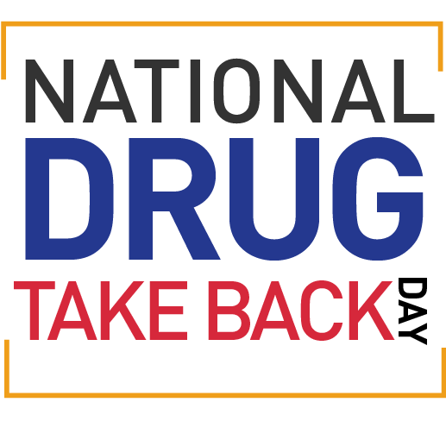
National Prescription Drug Take Back
Each year, the U.S. Drug Enforcement Administration periodically hosts National Prescription Drug Take Back events, where temporary drug collection sites are set up in communities for citizens to safely dispose of prescription drugs.
In April and October 2024, the Kaysville Police Department participated in drug takeback at Walgreen’s. The event provides an opportunity for citizens to safely dispose of expired and unused medications to prevent addiction and overdose deaths.
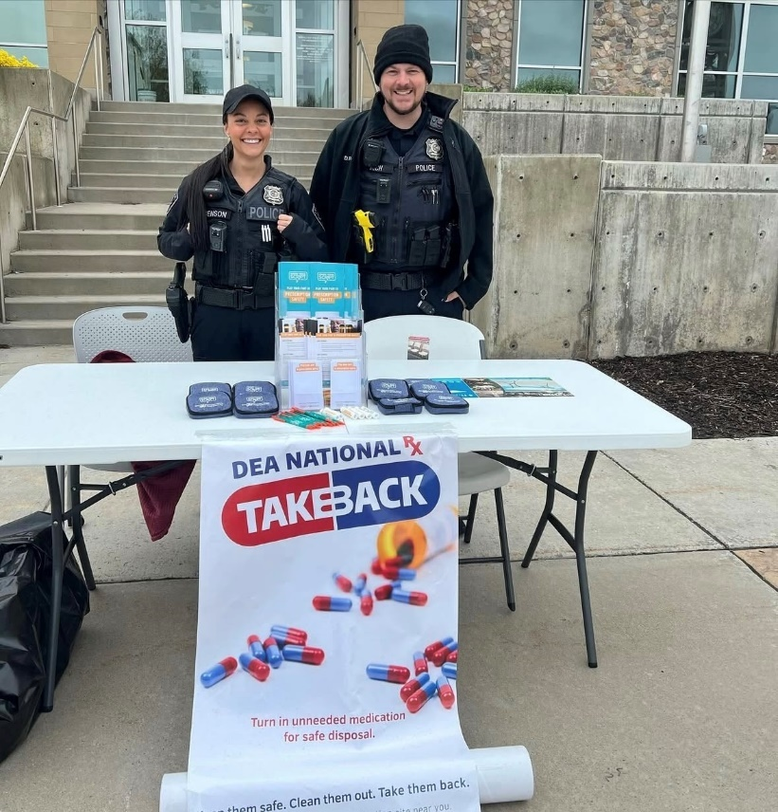

Jason W. Read Protect and Serve Foundation Donation
In April 2024, we received our third donation from the Jason W. Read Protect and Serve Foundation. The funds were used to purchase equipment that can be utilized by everyone in the department.
Jason Read was a Centerville police officer who was tragically killed during an off-duty motorcycle accident. The foundation is a non-profit that provides donations to law enforcement agencies to help protect officers while they are on duty.
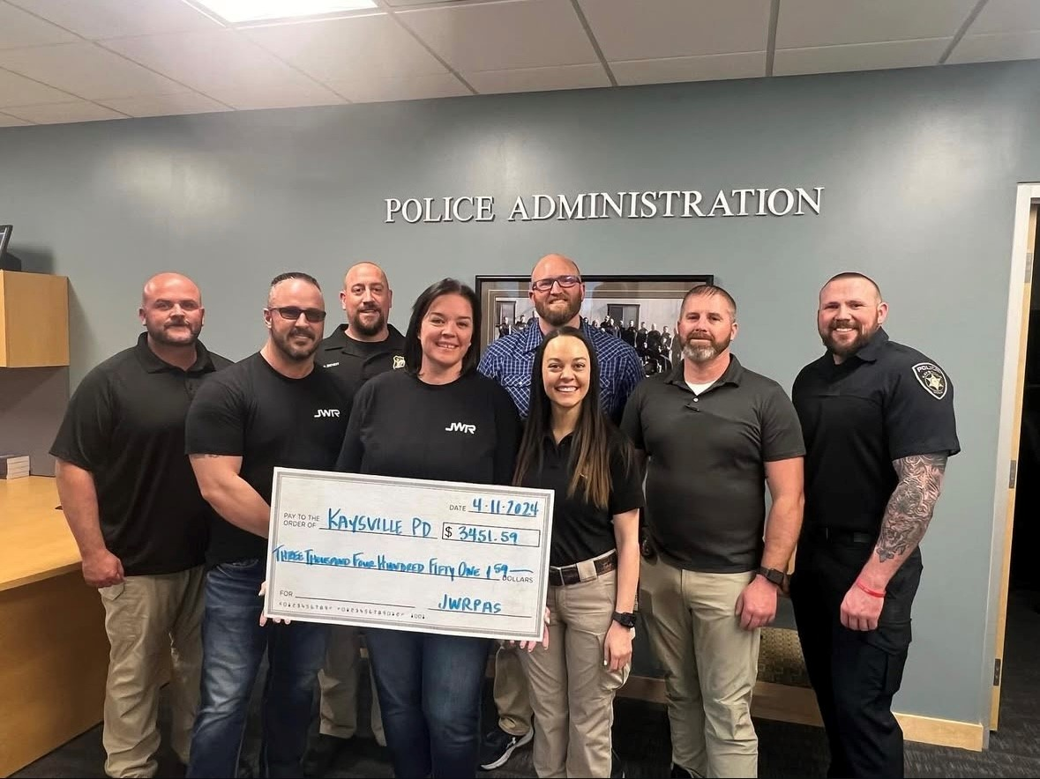

New Officer
In November 2023, Officer Blake Garrison graduated from the police academy. He successfully completed the Field Training Program in April 2024. We are confident that this new addition to our department will continue to have a positive impact on our growth and success.

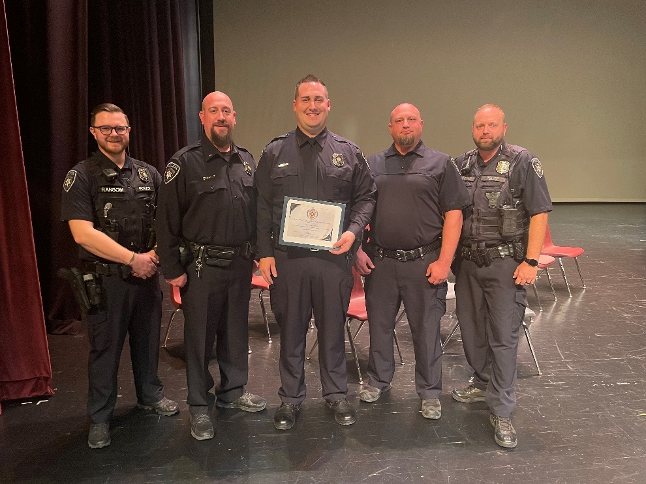

#copsandlemonade Challenge
Each summer, Kaysville officers look forward to lemonade stand season. This was the third year that we extended the Cops and Lemonade Challenge to all law enforcement agencies. The challenge was a huge success with participants from Davis, Weber and Salt Lake Counties.
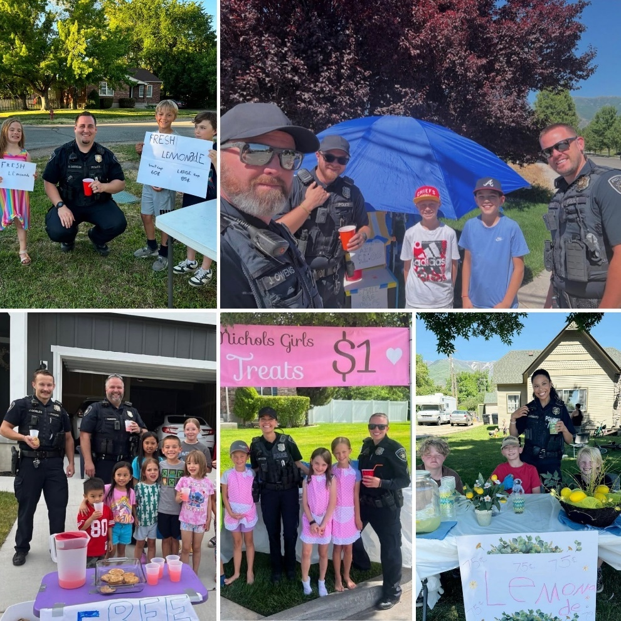

Cops and Kids Event
In December 2024, members of the Kaysville Police Department participated in the Cops and Kids event hosted by the Davis County FOP. Officers took the kids to breakfast at Texas Roadhouse and then shopped for Christmas gifts at Walmart.

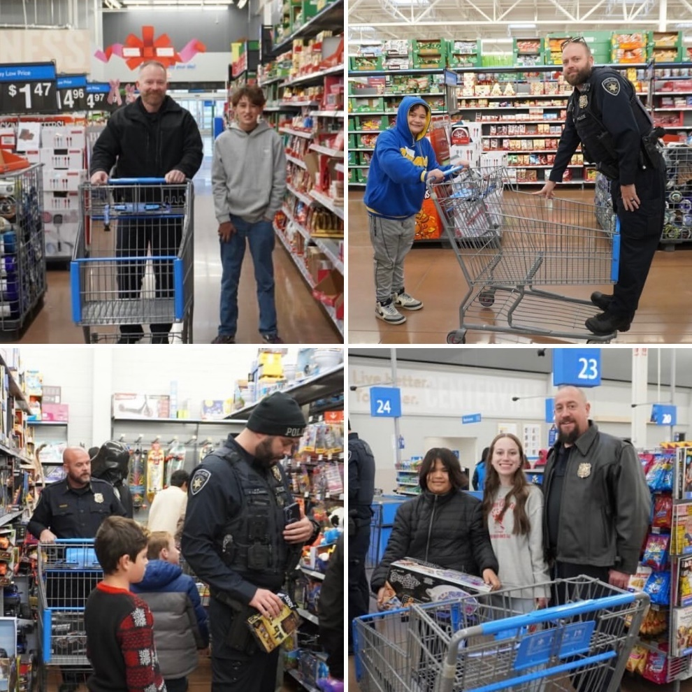

SafeWise Utah’s Safest Cities Report



Kaysville City held on to the number 2 spot for the second consecutive year! Kaysville was ranked the 2nd safest city in Utah by the SafeWise Utah’s Safest Cities report, making the list for the seventh year in a row.
The results are based on the most recent FBI crime report statistics and population data, narrowed down by the number of reported violent and property crimes in each city. They calculate the rate of crimes per 1,000 people in each city to directly compare the likelihood of these crimes occurring in cities with vastly different populations.
Below is an excerpt from the report:
According to our most recent State of Safety report, Utah is less concerned overall about crime and safety than most of the country, with the least worrisome issues being violent crime and gun violence. Chances are people who live in one of Utah’s 10 safest cities have even less to worry about, especially when it comes to violent and property crime.
The full SafeWise Utah’s Safest Cities report can be found at https://www.safewise.com/blog/safest-cities-utah.
Records and Evidence

In 2024, the records department processed 3,155 reports, 690 public and government (excluding the courts) records requests and 115 background checks.

The Evidence tech(s) booked in 1,109 pieces of evidence and released 187 items.

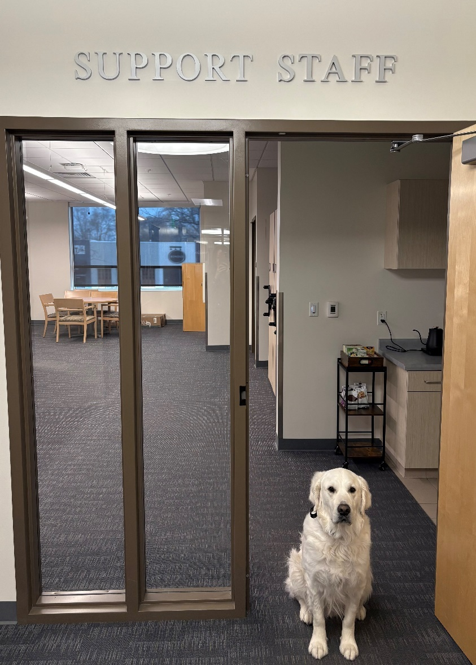

Department Awards

Each year in May during National Police Week, the Kaysville Police Department hosts an annual awards banquet to celebrate the year’s achievements and future perspectives.
Employee of the Year
Logan Nicholas
The Kaysville Police Department recognizes Officer Logan Nicholas for his exemplary service throughout 2023.
Throughout his career, Officer Logan Nicholas has exemplified professionalism in the performance of his duties. Assigned to the patrol division, he routinely receives commendations for his efforts and is consistently among the highest statistical performers in patrol, year after year.
The high standards that Officer Nicholas sets are a great example and benchmark for exceptional performance making him ideally suited to represent the Kaysville Police Department as the Officer of the Year.
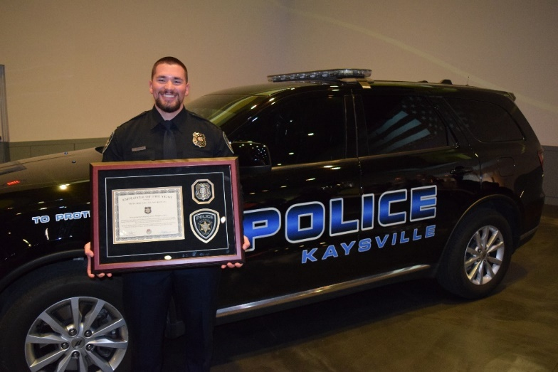
Distinguished Service Award
Stuart Palmer
In recognition for Stuart Palmer’s exemplary service rendered in mental health.

As the Kaysville Police Department’s Mental Health Coordinator, Stuart Palmer has established a crucial program within the police department. Mr. Palmer has employed his therapeutic expertise to help employees, and their families mitigate the difficult impacts of law enforcement careers.

His past experience as a police officer has given him a unique skill set of knowledge and abilities that enable him to help law enforcement officers and their families as ell as aid officers in their dealings with those in crisis.

Stuart Palmer’s efforts in this capacity are a credit to himself and the Kaysville Police Department.

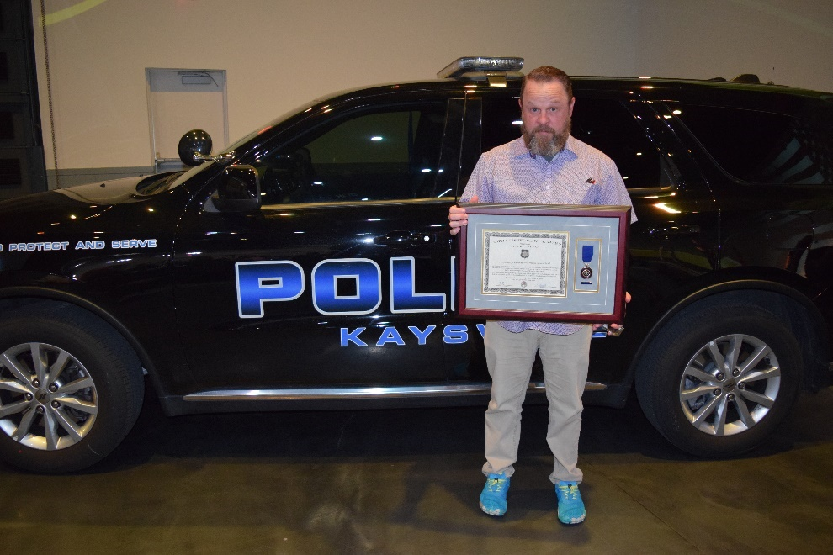

Distinguished Service Award
Jeremy Owens
In recognition for Jeremy Owens’ exemplary service.

From 2021 to 2024, Sgt. Owens has worked to develop the Professional Standards and Training (PSAT) position. In this role, he has streamlined the processes crucial to strengthening the department’s professionalism including training and internal affairs.

He has been the point of contact for many of the department’s programs including equipment, fleet, building maintenance, and software systems. He also administers the COP/POP and traffic safety programs and has established the PSAT position as one crucial to the department’s well-being.

Sgt. Owens’ professionalism and dedication are a credit to himself and the Kaysville Police Department.

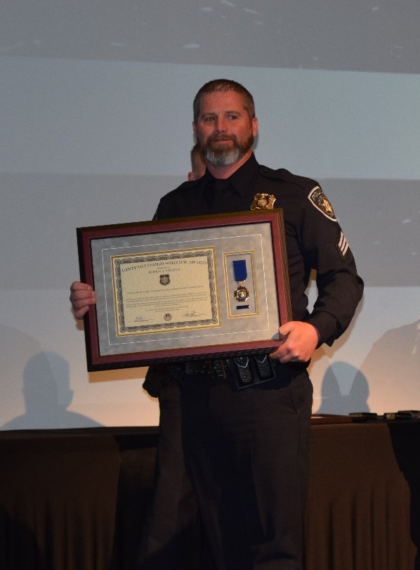

Lifesaving Award
Kalawai Delos Santos
In recognition for the lifesaving actions taken by Officer Kalawai Delos Santos on January 31, 2023.

While on routine patrol, Officer Delos Santos responded to a medical emergency. Upon his arrival he located a person who was not breathing and did not have a pulse. He performed lifesaving CPR measures and was able to revive the subject who was subsequently transported to a hospital.

Officer Delos Santos’ quick thinking and decisive actions saved this person’s life. His actions are a credit to himself and the Kaysville Police Department.

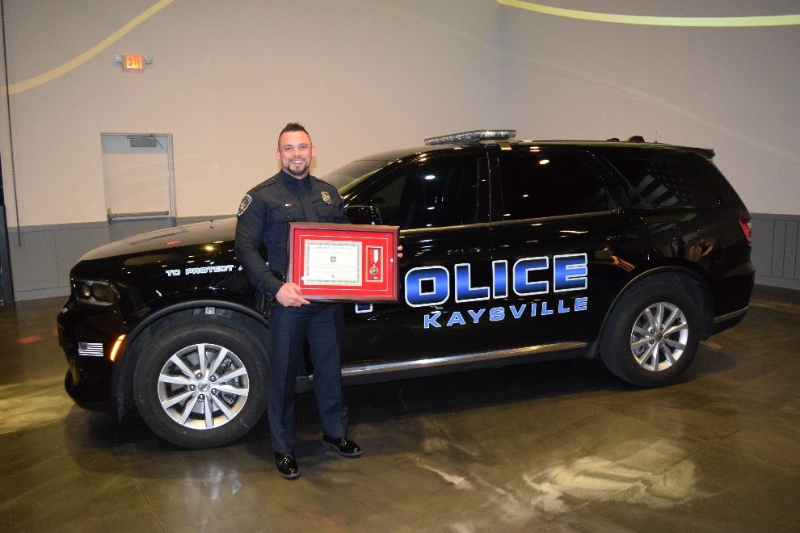

Unit Citation
Officer Jackson, Officer L. Nicholas, Det. Kendu Givens, Officer Moser and Officer Ransom
In recognition for their quick-thinking and decisive actions taken on August 2, 2023.

KPD Officers responded to a call involving an intoxicated suspect armed with a gun making threats towards his family. Upon their arrival, officers swiftly evacuated the family, ensuring their safety and searched for the suspect who had fled the scene.
Despite the suspect’s attempt to evade capture, the officers’ resourcefulness ultimately led to his apprehension thereby ensuring community safety and security.
The actions of these officers are a credit to themselves and the Kaysville Police Department.

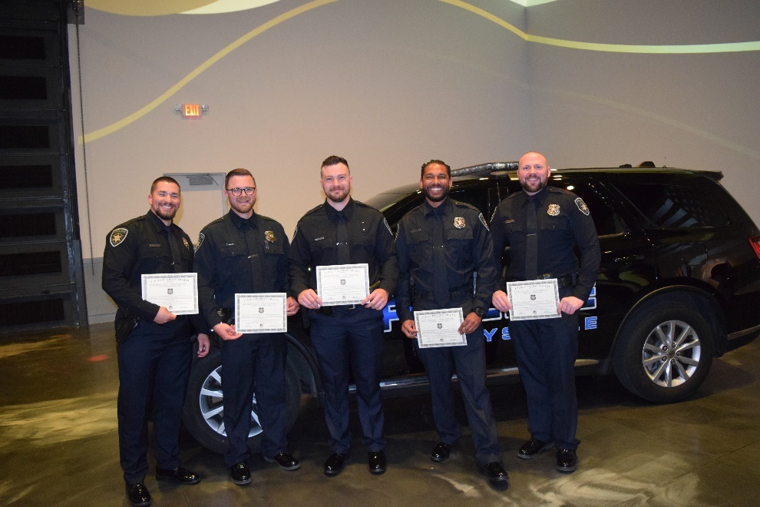

Unit Citation
Sgt. Lacy Turner, Sgt. Jensen, Det. Jacob Seifert, and VA. Jennifer Winchester
In recognition for their quick-thinking and decisive actions taken to ensure the safety of a Domestic Violence victim.

Victim Advocate Winchester was alerted to a victim urgently requiring protection from a relentless domestic perpetrator. Recognizing the need for immediate police intervention, VA Winchester collaborated with Sgt. Turner, and VAWA Det. Seifert to expedite the police response. Det. Seifert coordinated with other agencies to gather crucial information on the perpetrator’s whereabouts and organized patrols around the victim’s residence for safety. With assistance of Sgt. Jensen, the V-Fast liaison, a swift action plan was devised resulting in the perpetrator’s arrest, ultimately saving the victim’s life and alleviating their emotional distress.
The actions taken by these employees are a credit to themselves and the Kaysville Police Department.

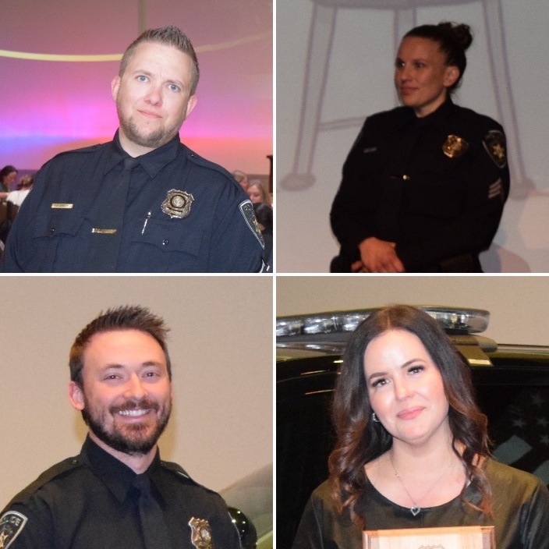

Unit Citation

Officer Collings, Officer Wallace, Officer Stanford and Officer Gobles

In recognition for their quick-thinking and decisive actions taken on December 29, 2023.

On this date, Officer Collings initiated a traffic stop on a vehicle for a traffic offense, but the occupants refused to comply, prompting a pursuit. The chase escalated as the suspect vehicle swerved across lanes on southbound I-15, ending in a crash near the Park Ln exit in Farmington.

Officer Collings, supported by Officers Wallace, Gobles and Stanford, successfully apprehended the occupants after drawing their duty weapon’s and issuing commands. A subsequent investigation revealed that the occupants were involved in multiple vehicle burglaries, with stolen items recovered from the suspect vehicle aiding in their arrest and bringing closure to several victims and likely eliminated other crimes from occurring.

The actions of these officers are a credit to themselves and the Kaysville Police Department.

