

ANNUAL REPORT 2017


Table of Contents

2017 Organizational Chart 3-4
Mission Statement 5
Activity Summary 6
Police Service Calls 7
Police Service Calls Time Analysis 8
Cases 8
Arrests 9
Traffic Statistics 10
Investigations Division 11
Pharmaceutical Disposal Program 13
Grant Funding 13
Notable Events 14-26
Department Awards 27-29

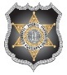
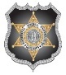
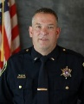
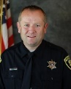
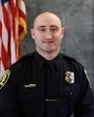
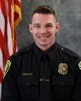
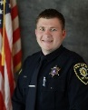
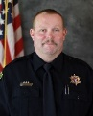
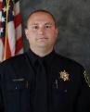
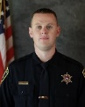
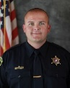
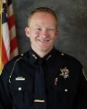

Victim Advocate
Jennifer Winchester
Lieutenant
Kenton Pies
SRO Davis High
Ryan Wilko
SRO Mountain High
Cade Bradshaw
D.A.R.E. Officer
Justin Stanford
Detective Sergeant
Shawn McKinnon
Detective
Mike Moon
Detective
Brandon Woolf
Detective
Mike Criddle
Investigations Division
Support Services
Crossing Guards
(20)
Records/Dispatch
Evidence Custodian
Samantha Smith
Assistant Chief
Seth Ellington
Chief of Police
Sol Oberg
Metro Narcotics Agent
Kaysville Police Department
2017 Organizational Chart
Support Services Supervisor
Jessica Busk

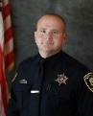
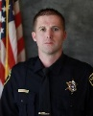
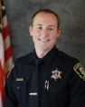
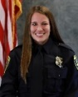
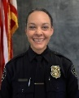
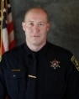
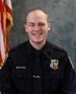
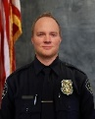
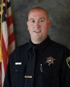
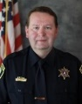
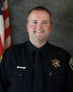
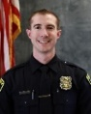
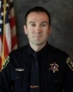
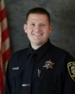
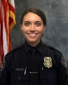
Patrol Division
Lieutenant
Paul Thompson
Chief of Police
Sol Oberg
Assistant Chief
Seth Ellington
Patrol Sergeant
Jeremy Owens
Patrol Officer
Jeff Randall
Patrol Officer
SRO Kaysville Jr.
Lacy Turner
Patrol Officer
Alexis Linton
Patrol Officer
SWAT Team
Josh Steadman
Patrol Officer
Devan Rich
Patrol Officer
Colton Bartleson
Patrol Sergeant
Preston Benoit
Patrol Officer
Daron Heslop
K-9 Officer
Matt Thurgood
Patrol Officer
Josh Danielson
P.O.P. Officer
SRO Centennial Jr.
SWAT Team
Mike Martinez

Patrol Officer
SRO Fairfield Jr.
Jordan Nicholas
Patrol Officer
Crystal Isaacson
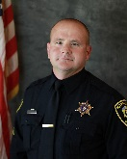
Kaysville Police Department
2017 Organizational Chart
Lieutenant
Paul Thompson

Mission Statement

The mission “to protect and serve” states the essential purpose of the Kaysville Police Department.

The Department protects the right of all persons within its jurisdiction to be free of criminal attack, to be secure in their possessions, and to live in peace.

The Department serves the people of Kaysville in a professional manner; and it is to these people that the police department is ultimately responsible.

Activity Summary
 | 2016 | 2017 | % Change
Total Police Service Calls | 8,405 | 9,665 | 15.0%
Average Daily Police Service Calls | 23.0 | 26.5 | 15.2%
Cases | 2,686 | 2,834 | 5.5%
Average Daily Cases | 7.4 | 7.8 | 5.4%
Average Emergency Response Times | 8:16 | 7:53 | -4.6%
Arrests | 354 | 382 | 7.9%

Part I Index Crimes (Crime Index)* | 286 | 318 | 11.2%
Homicide | 0 | 0 | 0.0%
Forcible Rape | 6 | 5 | -16.7%
Robbery | 4 | 3 | -25.0%
Aggravated Assault | 6 | 5 | -16.7%
Burglary | 52 | 66 | 26.9%
Larceny-Theft | 210 | 213 | 1.4%
Motor Vehicle Theft | 7 | 26 | 271.4%
Arson | 1 | 0 | -100.0%
Crime Index Per 1,000 Population | 9.39 | 10.18 | 8.4%

*Part I crimes (or violent crimes) compile the “crime index” used by the FBI to track our nation’s crime rate. If multiple Part I offenses are committed in the same criminal episode, only the most serious offense is reported, which may result in a variance in the number of total offenses reported below.

Crimes Against Persons | 187 | 211 | 12.8%
Sex Offense | 50 | 36 | -28.0%
Assault | 53 | 62 | 17.0%
Domestic Violence | 27 | 38 | 40.7%
Child Abuse / Neglect | 57 | 70 | 22.8%
Property Crimes | 487 | 374 | -23.2%
Vehicle Burglary | 84 | 91 | 8.3%
Theft | 145 | 121 | -16.6%
Fraud / Forgery / Financial Crimes | 60 | 55 | -9.1%
Vandalism | 130 | 107 | -17.7%

DUI Arrests | 24 | 20 | -16.7%
Drug Offenses | 79 | 109 | 38.0%
K-9 Deployments | 44 | 37 | -15.9%
SWAT Call Outs | 13 | 8 | -38.5%

Traffic Stops | 3,549 | 4,224 | 19.0%
Traffic Citations | 2,821 | 2,833 | 0.4%
Traffic Accidents | 489 | 390 | -20.2%
Traffic Fatalities | 0 | 0 | 0.0%

Police Service Calls
The following graph shows the total number of calls for service received each year.

Top 10 Calls for Service
Suspicious Circumstance | 1,200
Extra Patrol | 673
Medical Assist | 641
Citizen Assist | 633
Alarm | 488
Traffic Accident | 485
Traffic Offense | 393
Vehicle Keys | 347
Community-Oriented Policing | 325
Juvenile Problem | 311

Police Service Calls Time Analysis
The following table shows the number of calls for service and the specific time and day they were received.

Hour | Monday | Tuesday | Wednesday | Thursday | Friday | Saturday | Sunday | Total
0000-0259 | 101 | 120 | 119 | 123 | 137 | 163 | 147 | 910
0300-0559 | 54 | 62 | 57 | 65 | 64 | 65 | 57 | 424
0600-0859 | 126 | 134 | 123 | 137 | 108 | 82 | 43 | 753
0900-1159 | 214 | 349 | 225 | 329 | 284 | 146 | 111 | 1658
1200-1459 | 234 | 293 | 280 | 255 | 266 | 162 | 141 | 1631
1500-1759 | 313 | 309 | 361 | 362 | 329 | 159 | 122 | 1955
1800-2059 | 173 | 200 | 200 | 196 | 204 | 150 | 114 | 1237
2100-2359 | 150 | 153 | 119 | 187 | 177 | 192 | 119 | 1097
Total by Day | 1365 | 1620 | 1484 | 1654 | 1569 | 1119 | 854 | 9665

Cases
Cases are created from police service calls that require documentation by the responding officer.

Top 10 Cases
Traffic Accident | 385
Suspicious Circumstance | 293
Welfare Check | 164
Theft | 135
Agency Assist | 132
Traffic Offense | 123
Juvenile Problem | 114
Lost or Found Property | 105
Citizen Assist | 102
Domestic | 100

Arrests
An arrest consists of when criminal charges are filed on an individual; regardless if the individual was cited and released, served with a summons to appear in court, or physically arrested and booked into jail.

Traffic Statistics

Traffic Stops and Citations

Accidents
Traffic accidents are categorized as either property damage only or with personal injury to someone involved in the accident. The following statistics show the number of traffic accidents, categorized by accident type.

Investigations Division
In 2017, the Investigations Division investigated 377 total cases. Below is a comparison between the number and types of cases that were investigated in 2016 and 2017. The pie chart shows the percentage of types of cases investigated.

Case Type | 2016 | 2017
Burglary | 82 | 101
General Investigation | 42 | 28
Theft | 61 | 54
Fraud/Forgery | 58 | 49
Child Abuse Neglect Report (CANR) | 43 | 77
Sex Offense | 34 | 34
Crime Against Person | 33 | 13
Crime Against Property | 7 | 3
Death Investigation | 21 | 15
Robbery | 3 | 3
Total | 384 | 377

Registered Sex Offenders
Registered sex offenders are required to register and provide information required by statute to the Department of Corrections or registering entity every six months. Offenders who are not under the supervision of AP&P must register with the Police Department or Sheriff’s Office that has jurisdiction over the area where the offender resides.

The following is a breakdown of the different types of sex offender registrations in Kaysville City:

15 Active (offenders who still have a legal obligation to register with the State of Utah)
4 Inactive – Other (offenders whose conviction is not registerable or reduced to a non-registerable offense)
2 Inactive – Out of Area (offenders who have listed a secondary or temporary address in Kaysville City but do not primarily reside in the city)
4 Inactive – Registration Expired (offenders who have been terminated from the registry)
1 Incarcerated (offenders who are incarcerated)
1 Pending (new offenders awaiting verification)

In 2017, there were a total of 27 registered sex offenders residing in Kaysville City and detectives tracked 13* sex offenders with active registrations. Kaysville detectives conducted 24 sex offender registration compliance checks and had 100% compliance from all offenders in the city.

*2 of the 15 active offenders were under the supervision of Adult Probation & Parole.

Pharmaceutical Disposal Program
The Kaysville Police Department provides a disposal bin for the public to safely and confidentially dispose of their unwanted or expired medication. In the year 2017, the Kaysville Police Department destroyed 766.42 pounds of prescription drugs that were received in the pharmaceutical disposal bin.

 | 2015 | 2016 | 2017
Medications received for disposal | 550.20 lbs | 590.64 lbs | 766.42 lbs

Grant Funding
In 2017, the Kaysville Police Department received the following grant funding to pay for services and programs to benefit Kaysville City:

State Asset Forfeiture Grant  - $1,500  - State of Utah; one time funding  - 40mm less lethal launcher | Justice Assistance Grant (JAG)  - $4,500  - State of Utah; one time funding  - Fitness equipment
Accident Reduction  - $8,042  - Highway Safety; one time funding  - Radar trailer with traffic monitoring software | Alcohol Drug Free Community Grant  - $10,000  - State of Utah; one time funding  - Body cameras for officers
Alcohol Enforcement Funding  - $26,900  - State of Utah; one time funding  - Overtime DUI enforcement shifts | Beer Tax Funding  - $40,000  - State of Utah; one time funding  - In-car cameras for patrol vehicles
Victim Advocate Services
- $128,138
- Federal; 2-year grant cycle
- Victim advocate

Notable Events

NAACP First Responder Award
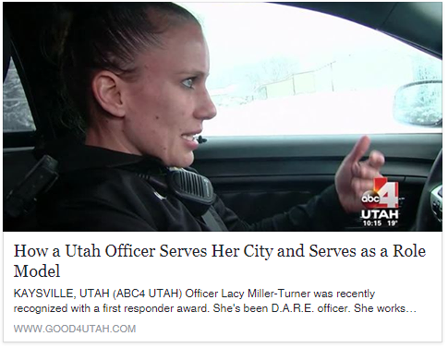

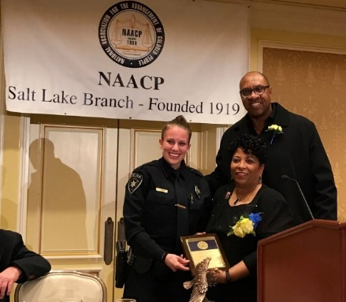
On January 16, 2017, Officer Lacy Turner was presented with the NAACP First Responder Award at the 33rd annual Martin Luther King Banquet. The award recognizes recipients to “celebrate the men and women who serve our communities every day.”

Officer Turner was also represented on ABC4’s Behind the Badge, a segment that shines a well-deserved light on law enforcement officers, showing how and why they choose to protect and serve.

Goldenwest Credit Union Robbery
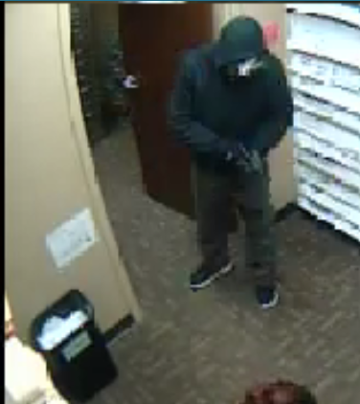
On February 11, 2017, there was a robbery at the Goldenwest Credit Union, located at 131 West 200 North. Kaysville officers and detectives investigated the incident, which resulted in the suspect being federally indicted for this case and several other robberies that occurred in Davis County.
Surveillance footage from Goldenwest Credit Union


Beyond the Badge

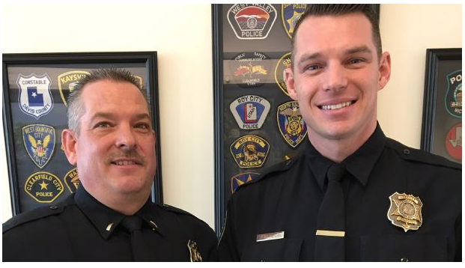
In February 2017, Officer Justin Stanford was nominated for KSL’s Beyond the Badge award for the great connections he has made with the community and our schools through teaching the D.A.R.E. program. The award recognizes the good work that Utah’s public safety officers do every day to make each of our lives better. Officers are nominated by their respective police chiefs, sheriffs and supervisors, and the general public.

Utah Peace Officers Association Officer of the Year Award

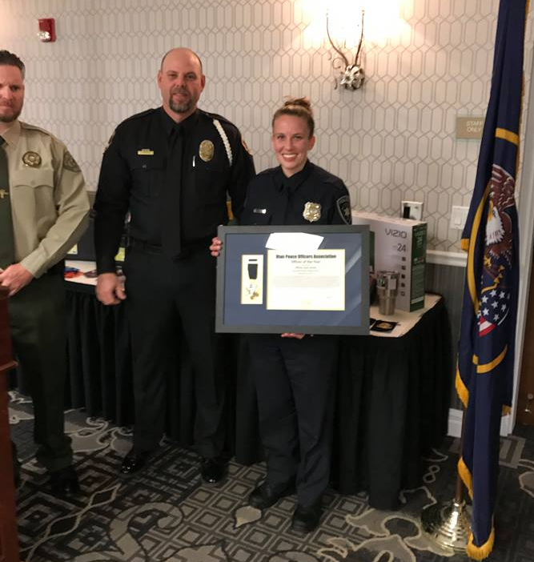
In March 2017, Officer Lacy Turner was awarded Officer of the Year by the Utah Peace Officers Association. The award is given by the Utah Peace Officers Association for outstanding service to citizens of the state of Utah.

Special Olympics Torch Run

On May 24, 2017, officers from the Kaysville Police Department proudly participated in the 2017 Davis County Law Enforcement Torch Run for Special Olympics.
The Torch Run was started in 1981 by Wichita, Kansas Police Chief Richard LaMunyon to involve local law enforcement personnel in the community and to support Special Olympics.
Officers carry the “Flame of Hope” down the streets of their communities in support of Special Olympics athletes. The Law Enforcement Torch Run raises awareness for individuals with intellectual disabilities, inviting the community to join them in accepting and including people with intellectual disabilities in all aspects of their lives.
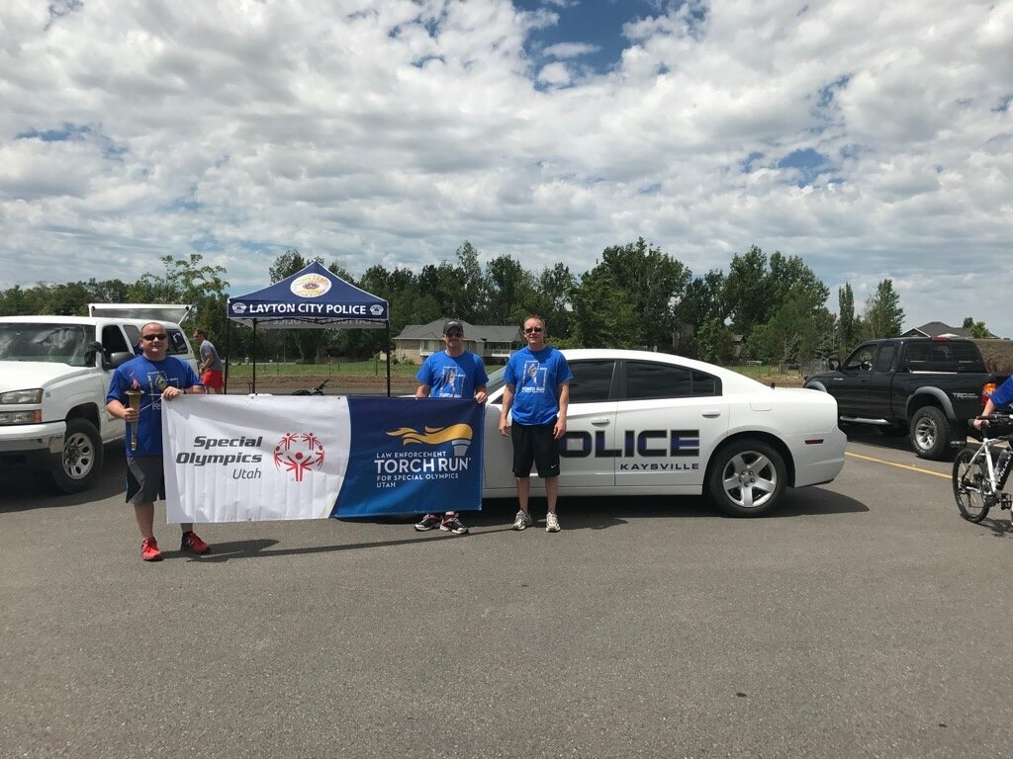
Lt. Thompson, Sgt. Owens, and Chief Oberg
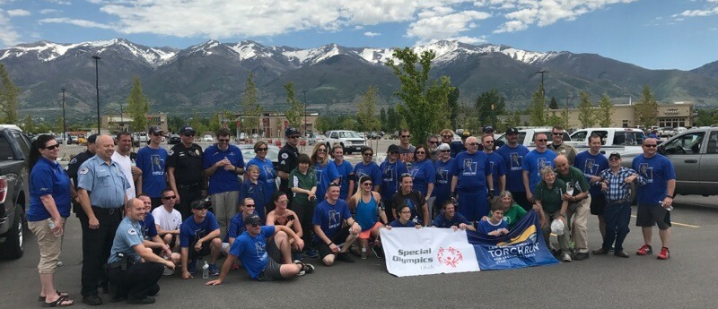
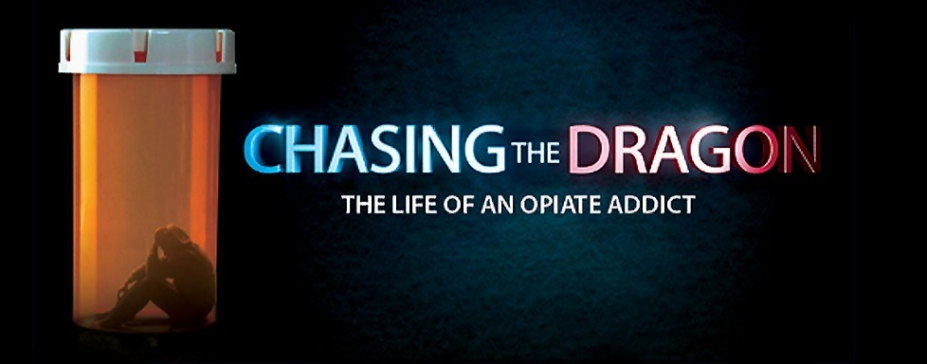
Chasing the Dragon

On June 21, 2017, the Kaysville Police Department hosted a substance abuse awareness community event, which included a free screening of Chasing the Dragon: The Life of an Opiate Addict, a powerful documentary produced by the FBI and DEA aimed at educating students, young adults, and families about the dangers of addiction. The event was well attended and offered valuable information to citizens on the substance abuse.
The screening of the documentary was followed by an expert panel of Q&A with:
- Agent Scott Byington, Davis Metro Narcotics Strike Force
Pharmaceutical Investigator
- Aaron Clark, U.S. Attorneys Office
An Assistant U.S. Attorney for over 11 years, spending the last 7 years prosecuting federal narcotics crime in both Utah and San Diego, CA.

- Dr. Michael Webb
A physician for 28 years who has practiced in Davis and Weber counties since 1998, treating a number of patients for complications of narcotic overdose and addiction.

- Dr. Todd Soutor, Davis Behavioral Health
Davis Behavioral Health offers specialized programs for substance abuse and addiction.

Narcan
In 2017, all Kaysville officers were supplied with and trained on the use of NARCAN, the first FDA-approved nasal form of naloxone for the emergency treatment of a known or suspected opioid overdose. NARCAN counteracts the life-threatening effects of opioid overdose. Kaysville officers administered NARCAN on six different incidents throughout the year.
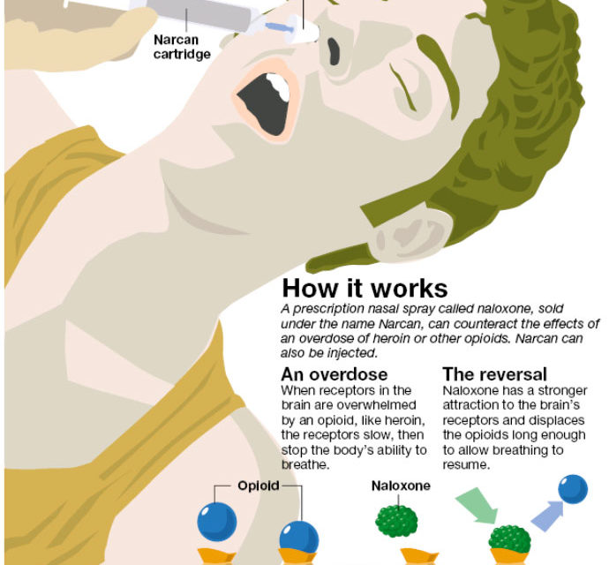

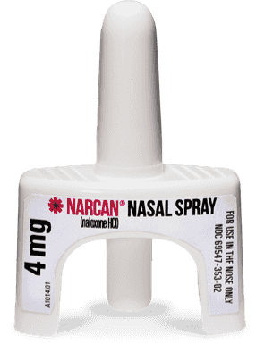
#copslovelemonadestands
During the summer of 2017, Kaysville police officers were busy with the second year of #copslovelemonadestands, a social media campaign that has become a big hit with the community.

The police department received daily requests for officers to stop by various lemonade stands throughout the city. The officers enjoyed supporting young entrepreneurs and building positive relationships with the children in our community.
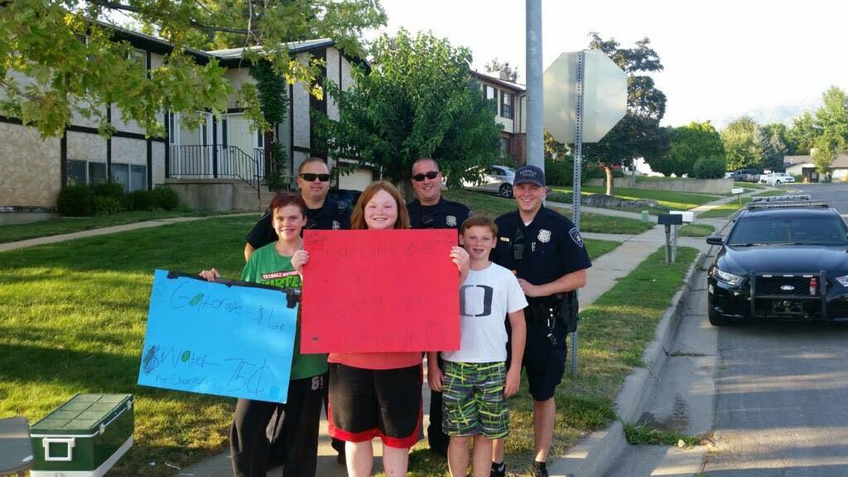
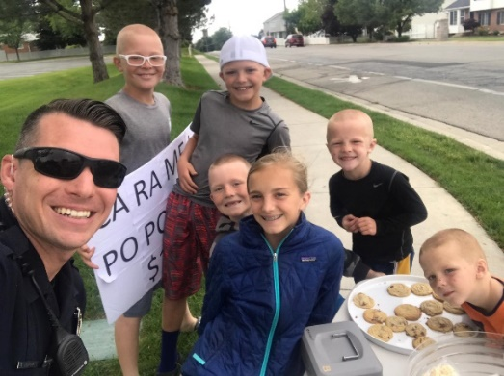
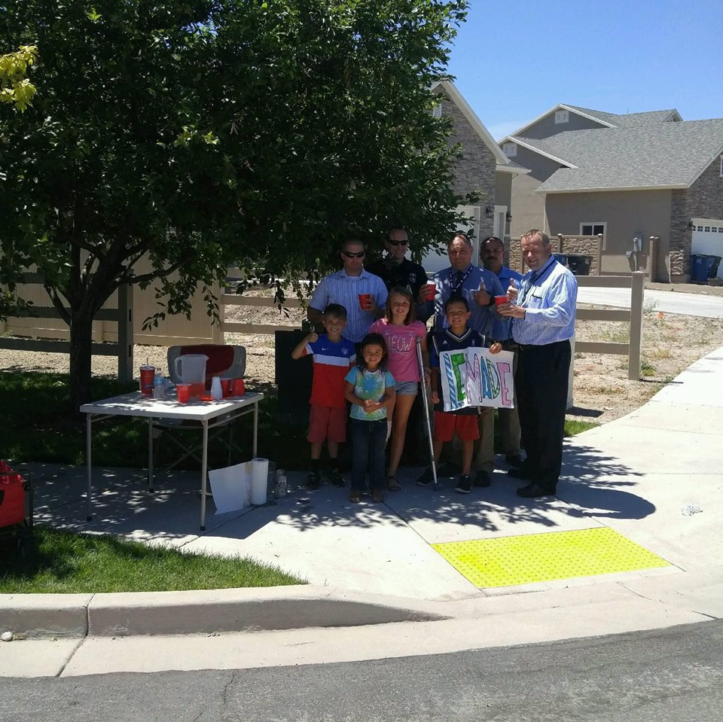
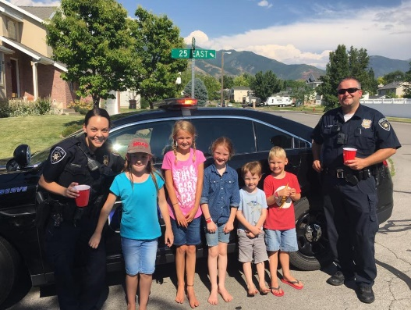
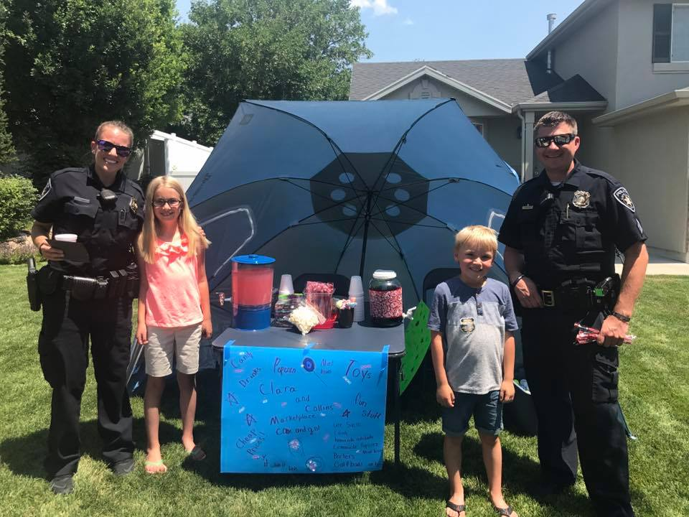
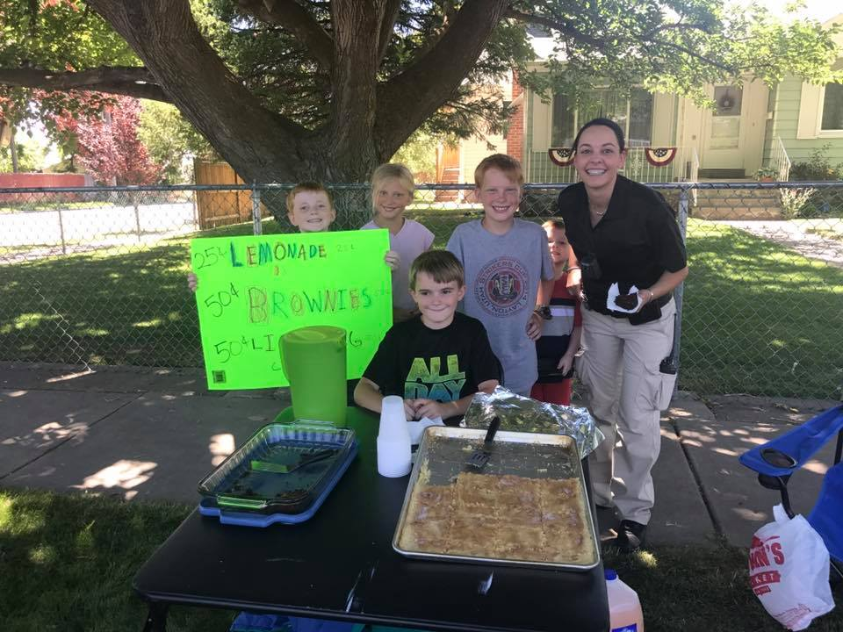
Larry H. Miller Tour of Utah
On August 4, 2017, the Kaysville Police Department assisted with traffic control for Stage 5 of the Larry H. Miller Tour of Utah, one of the top professional cycling events in North America. The race started in Layton and officers helped by shutting down traffic along Highway 89 into Farmington.
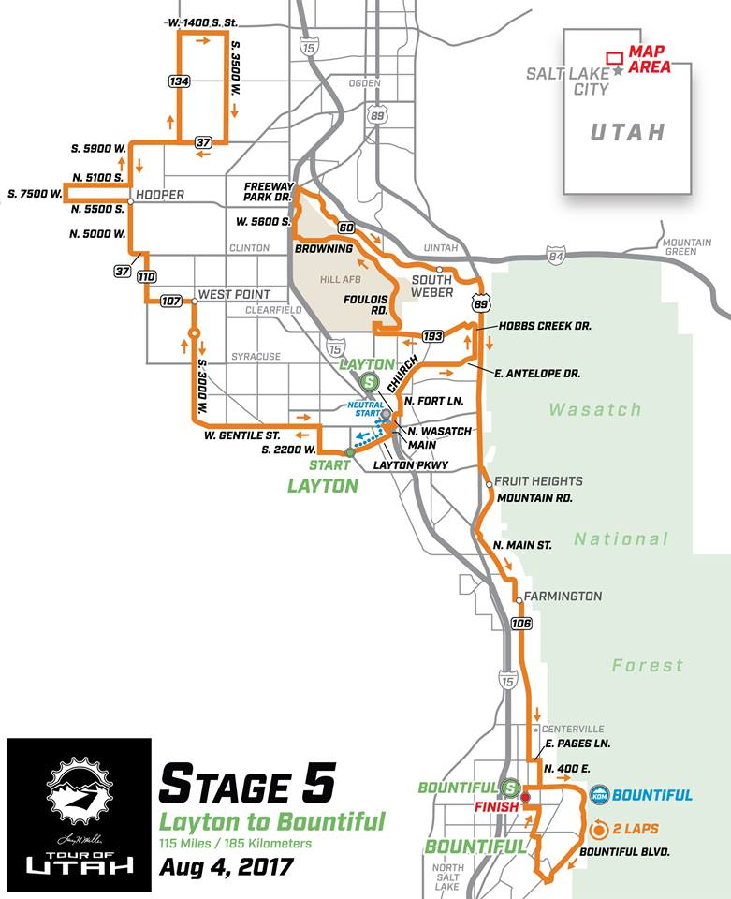
Davis High School Restricted Parking
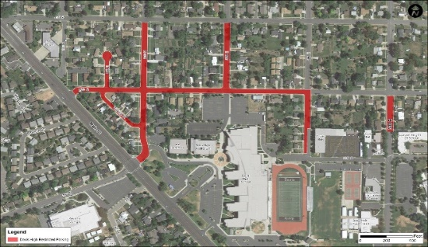
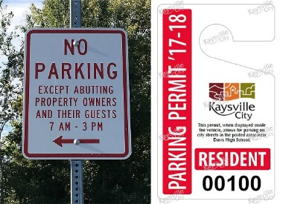
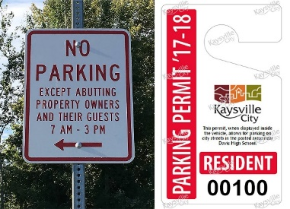
In August 2017, the city implemented new parking restrictions for the areas surrounding Davis High School where any vehicle parked on the road of restricted areas between 7 AM and 3 PM would be subject to citations if they didn’t have the proper parking pass visibly displayed. Kaysville City also transitioned into having parking citations as a civil violation rather than going through the Justice Court process.
Map of Davis High School restricted parking areas

Victim Services Program

The Kaysville Police Department was approved for grant funding by Utah Crime for a victim advocate position. In August 2017, the police department hired Jennifer Winchester as our victim advocate.
The Victim Services program provides emotional support and crises intervention to victims of all types of crime. Jennifer acts as a liaison for victims with law enforcement, prosecution, and other agencies by attending law enforcement interviews, forensic medical examinations, and court hearings with or on behalf of the victim.
After a crime is committed, a needs assessment is completed with the victim and referrals for counseling, shelter, and legal assistance are provided based on the victim’s needs. Other services are provided through the Victim Service program, including assistance in obtaining protective orders; filing crime victim reparation forms, victim impact statements, employer/landlord intervention; and additional services as needed.
Vehicle Burglaries
In 2017, over 90 vehicle burglaries were reported to the Kaysville Police Department. Since vehicle burglaries are often a crime of opportunity, we constantly urge citizens to take the steps to protect themselves and their property by making sure no valuables are left inside their vehicles, lock their vehicles, and make sure garage doors are closed at night.
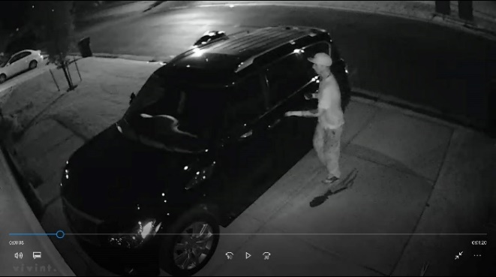
Video surveillance from a Kaysville resident

In September 2017, Kaysville officers received a call for a vehicle burglary in progress and apprehended the suspect, who was responsible for a large number of vehicle burglaries that had occurred in the city.
The Kaysville Police Department awarded the complainant in that case, David Nielson, with a Citizen Service Award for his help in the apprehension of the burglary suspect.

No Shave Fundraiser
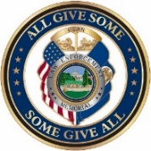

The Kaysville Police Department participated in the No Shave November charity event, allowing officers who made a $20 donation to grow facial hair for the months of October and November. The amount raised from the fundraiser was $560, which was donated to the Utah Law Enforcement Memorial.

Hometown Hero


In October 2017, Officer Justin Stanford was chosen as our “Hometown Hero” by the Hometown Values Magazine. They recognize those who have gone above and beyond to improve the world around them.
The recognition was titled “DARE officer extraordinaire!” and explains how Officer Stanford is making such a great positive impact in our schools and community. See an excerpt from the recognition below:

“Officer Stanford is a credit to the Kaysville Police force, and he is an asset to the DARE program. He deserves to be recognized as a hero for all of his efforts in strengthening and supporting the youth of Kaysville. Next year he is being deployed to the Middle East, and it will be very hard for the DARE program to find someone to fill his shoes. He is our Hometown hero!”

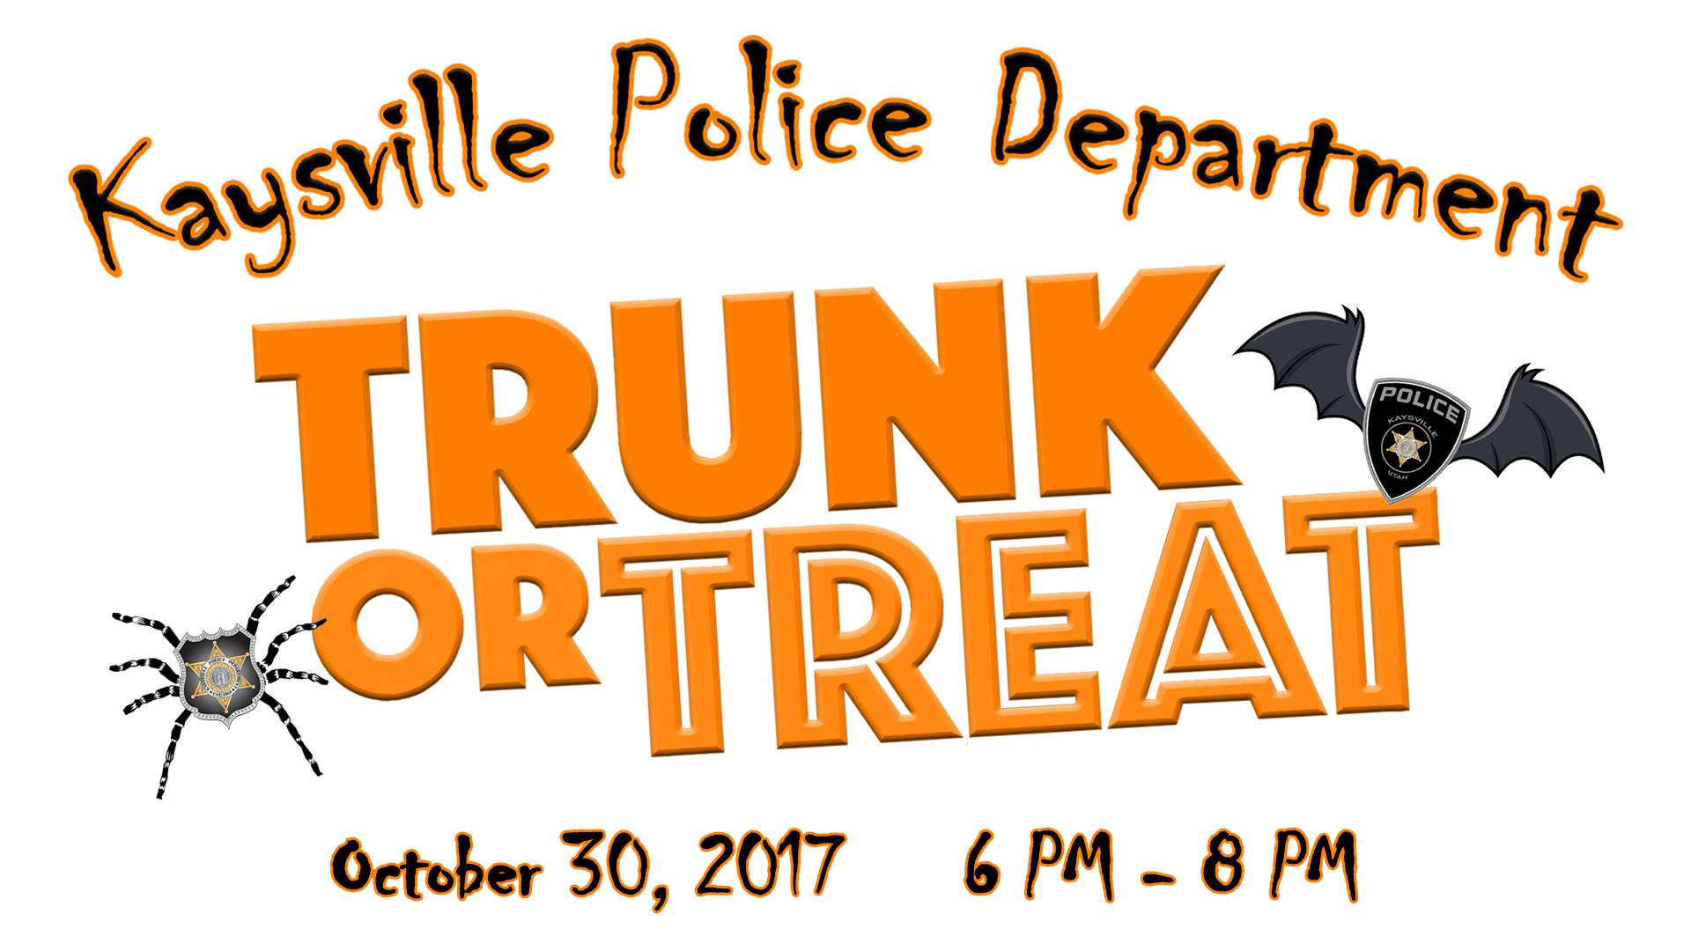
Trunk or Treat

On October 30, 2017, the Kaysville Police Department hosted its first Halloween Trunk or Treat. Parks & Recreation, Public Works, Power, and the City Administration departments all participated in this fun community event. We had an extremely great turnout and hope to continue the event annually each year.
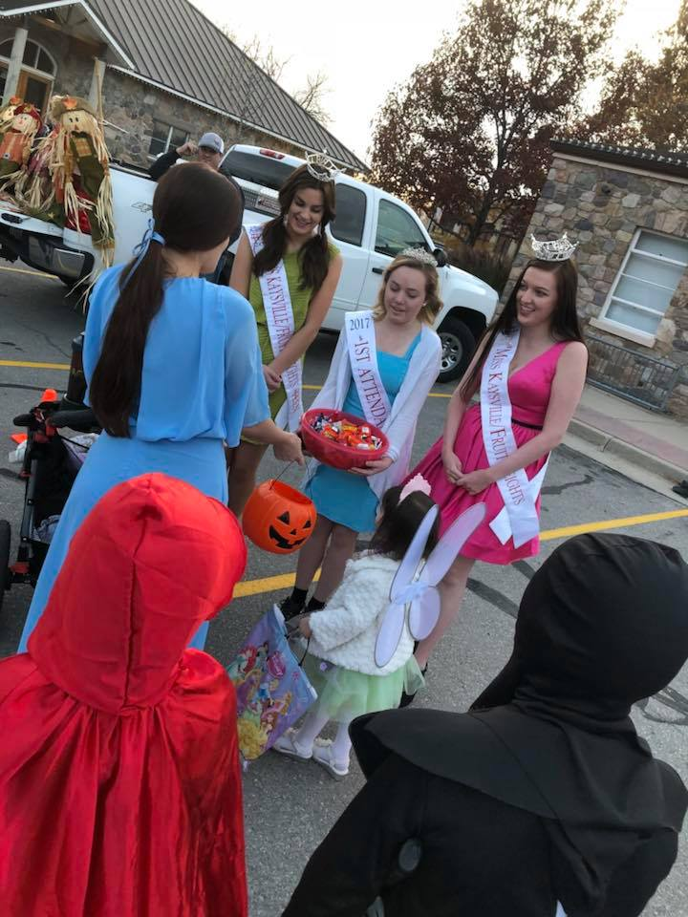
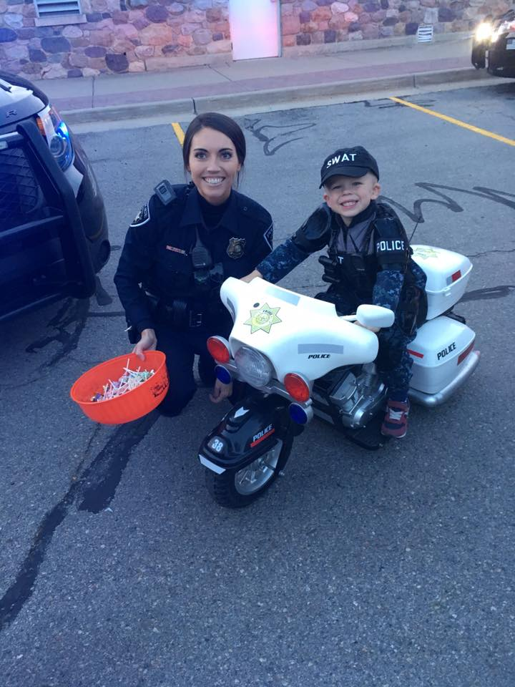
Miss Kaysville Fruit Heights Power Puff Girls
Officer Isaacson and a young recruit

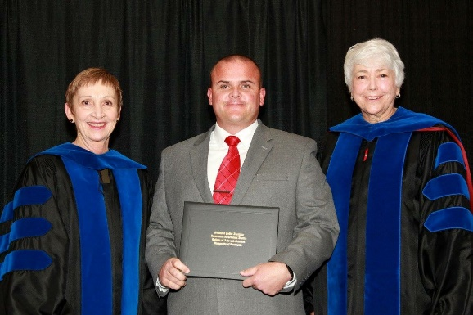
Southern Police Institute Administrative Officers Course

On November 9, 2017, Assistant Chief Seth Ellington graduated from the Southern Police Institute’s Administrative Officers Course in Louisville, Kentucky.
The Southern Police Institute is part of the Department of Criminal Justice at the University of Louisville. It is an advanced educational and training institute whose mission is to enhance the professional development of law enforcement practitioners.
The course is a 12 week in-residence, accredited college-level educational leadership development program. Assistant Chief Ellington represented the police department admirably and was well regarded by his peers and professors. He was the first police officer from Utah to graduate from this intensive leadership course.

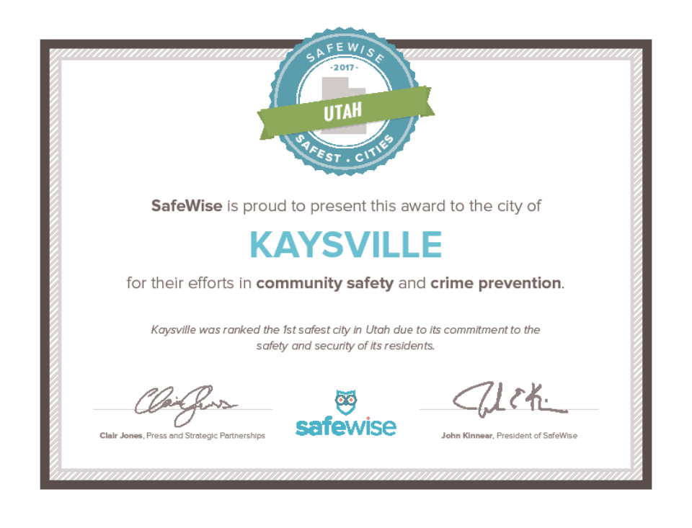Safewise Report 2017

Kaysville City was ranked the safest city in Utah by the 2017 SafeWise Report. The results were identified using the most recent FBI Crime Report statistics and population data, narrowed down based on the number of reported violent crimes and property crimes in each city, and also calculating the likelihood of these crimes occurring out of 1,000 people in each city.
Kaysville City was previously ranked the second safest city in Utah by the 2015 SafeWise Report.

Department Awards

Each year during National Police Week, the Kaysville Police Department hosts an annual awards banquet to celebrate the year’s achievements and future perspectives. In 2017, the following awards were given to officers, whose actions were a great credit to themselves and the Kaysville Police Department.

Unit Citation
The Kaysville Police Department recognized Lieutenant Pies, Lieutenant Thompson, Sergeant Ellington, Sergeant Benoit, Detective Owens, Detective Moon, Detective Woolf, Officer Heslop, Officer Anthony Thompson, Officer Randall, Officer Martinez, Officer Matt Thurgood, Officer Nicholas, Officer Cade Bradshaw, and Officer Turner for their actions taken on February 1, 2016. These officers responded to and investigated an armed car-jacking in Kaysville City.
The suspects robbed the driver of her vehicle at knife-point and fled the city. As they fled, the stolen vehicle was disabled in Centerville, while one suspect was apprehended. The suspects were arrested and criminally prosecuted for their crimes. The actions of these officers were critical in the dynamic moments of the event as well as the subsequent investigation.


Lifesaving Award

The Kaysville Police Department recognized Officer Lacy Turner for the lifesaving actions she took on March 4, 2016. While on routine patrol, Officer Turner was dispatched to a medical emergency. Upon her arrival, she located a person who was not breathing and did not have a pulse.
She performed lifesaving CPR measures and was able to revive the subject, who was consequently transported to the hospital. Officer Turner’s quick thinking and decisive actions saved the life of this person.
Unit Citation
The Kaysville Police Department recognized Lieutenant Paul Thompson, Sergeant Ellington, Sergeant Benoit, Officer Nicholas, and Officer Turner for their actions taken on March 31, 2016.
These officers responded initially to a house fire, later determined to be an arson. Upon their arrival, officers breached the fully-engulfed home and yard in an attempt to locate living persons. They heard gunshots and upon searching for the origin of the shots, located the arson suspect with a self-inflicted gunshot wound.
Officers summoned medical and facilitated fire department actions while containing the scene to protect the public. Though the suspect died, all other members of the community remained safe.
The actions of these officers in the dynamic moments of the event were crucial to the preservation of public safety and security.


Meritorious Service

The Kaysville Police Department recognized Officer Matthew Thurgood for his actions on October 23, 2016.
While on routine patrol, Officer Thurgood initiated a traffic stop on a vehicle and conducted an investigation into the occupants. After developing probable cause and searching the vehicle, he located an amount of illegal narcotics, burglary tools, and 11 catalytic converters.
A subsequent investigation revealed that the catalytic converters had been stolen from vehicles in the area and ultimately resulted in the successful closure of multiple theft cases.
Officer Thurgood’s initiative and decisive actions increased the public’s safety and security.

Lifesaving Award

The Kaysville Police Department recognized Officer Josh Danielson for the lifesaving actions he took on November 29, 2016.
While on routine patrol, Officer Danielson was dispatched to a medical emergency. Upon his arrival, he located a person who was not breathing and did not have a pulse.
He performed lifesaving CPR measures and was able to revive the subject, who was subsequently transported to a hospital.
Officer Danielson’s quick thinking and decisive actions saved the life of this person.


Distinguished Service

The Kaysville Police Department recognized Officer Lacy Turner for her community-policing initiatives.
While assigned as a Problem-Oriented Policing officer, Lacy Turner implemented several community policing initiatives that built trust between the Kaysville Police Department and our community.
Her programs and actions particularly relating to the city’s youth was recognized by the Governor’s Office, Kaysville City Council, the NAACP, schools, community groups, and media outlets.
The media coverage of these events promoted a positive, professional image of the Kaysville Police Department to tens of thousands of community members.

